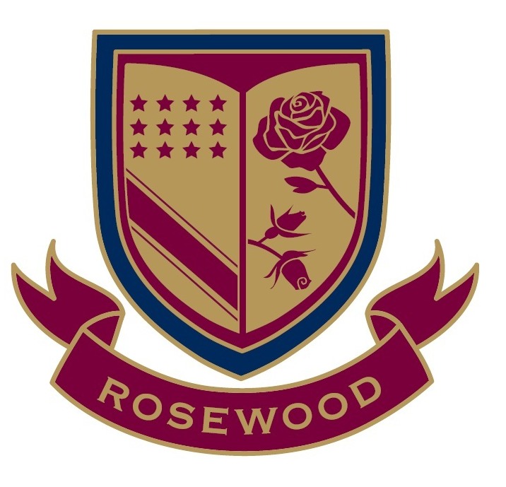

ROSEWOOD
129 Long Circular Road
rosewood.edu.tt

Mission
Together with parents, Rosewood is committed to educating the whole person with a rich bilingual curriculum and personal character formation and to encourage each student to cultivate intellect and character, leadership and service, faith and reason.

Vision
It is our goal to nurture and develop citizens of Trinidad and Tobago who are well grounded spiritually, morally, emotionally, and academically, with the ability to contribute to the family, the nation and the world.

Give the daughters of our nation the gift of a stimulating, enriching start to their education. Give them the Rosewood experience!

A Complete application consist of:

- Application Fee $150.00 TT

- An Application Form
Completed by the parent(s)

- An Applicant Statement
Completed by applicant

- Health Form
Completed by the parent(s)

- Recommendation Forms as Required
Completed by a teacher or
administrator at the
applicants present school
Middle – One
High – Two

- Current School Reports
For applicants to Jr. 3 – 6

- Past Two years Reports
For applicants Form 1 – 5

- IEP or Psychological Report
(if applicable)

- Passport Sized Photo of the Applicant

- Copy of Passport or Birth Certificate

- Copy of Parents ID or DP

- Copies of all Immunization Records

- Principal Interview and Assessment
For all applicants

